**EXPERIMENT NO. 07**

SIMULATION OF DYNAMIC ROUTING PROTOCOLS (BGP) USING CISCO PACKET TRACER.

**EXPERIMENT NO. 7**

**AIM**: To simulate dynamic routing protocols (BGP) using Cisco Packet Tracer.

**OBJECTIVES:**

1. To Simulate BGP routing protocol, check the updated routing tables and check the connectivity among devices.

**SOFTWARE:** Cisco Packet Tracer.

**SCENARIO:**

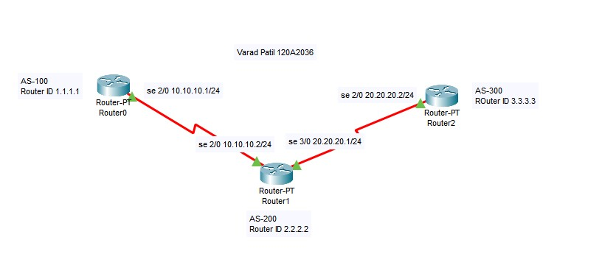

**Procedure for BGP:**

Step 1: Configure the router interfaces for IP addresses as shown in the scenario

Step 2: Set clock rate on at least one serial interface belonging to different networks

Step 3: Activate all the interfaces

Step 4: configure autonomous system (AS) number on each BGP router as shown in scenario above.

Step 5: configure ID on each BGP router as shown in scenario above.

Step 6: Run ip interface brief on each router

Step 7: Run show-running-config on each router

Step 8: Run neighbor command on each BGP router (e.g. neighbor 10.10.10.2 remote-as 200 on router 0)

Step 9: Run network command on BGP router 0 for loop back interfaces (e.g. network

100.100.100.0 mask 255.255.255.0 and network 101.101.101.0 mask 255.255.255.0 )

Step 10: Check directly connected networks for each router. (Using show ip route) Step 11: Check updated routing tables on each router. (Using show ip bgp)

**Router0**

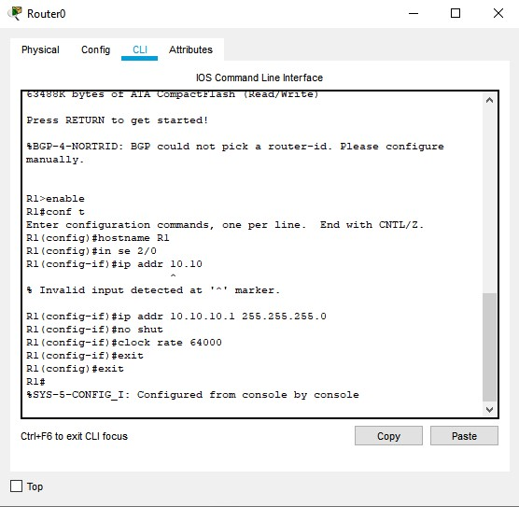

**Router1**

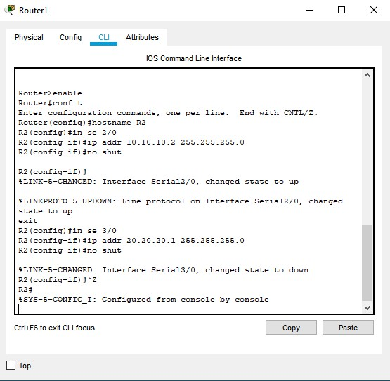

**Router2**

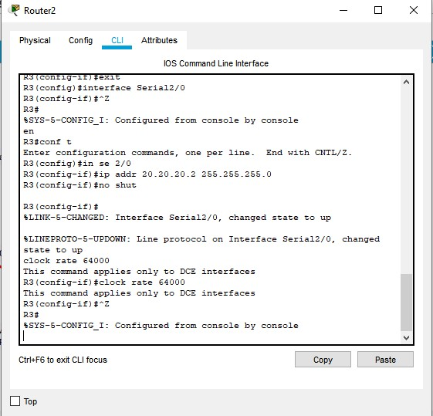

**UPDATED ROUTING TABLE:**

**Router0:**

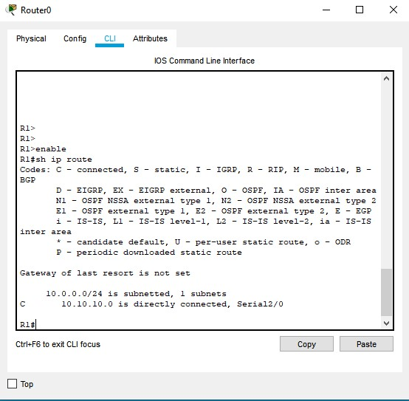

**Router1:**

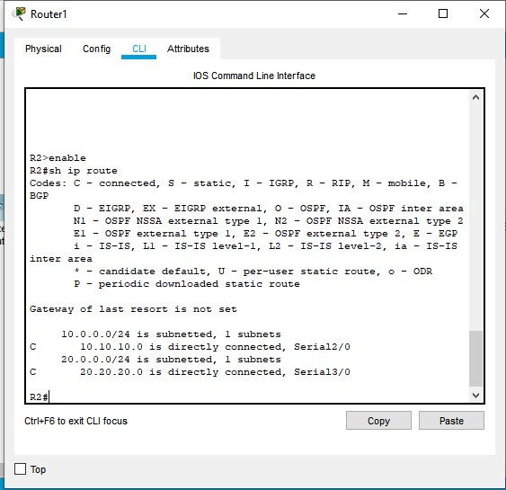

**Router2:**

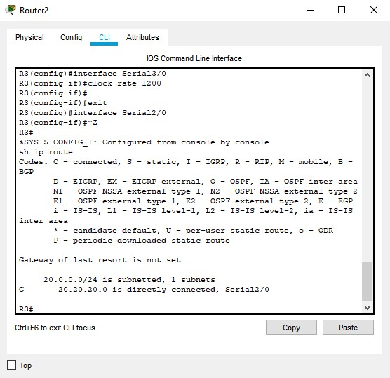

**BGP CONFIGURATION:**

**Router0:**

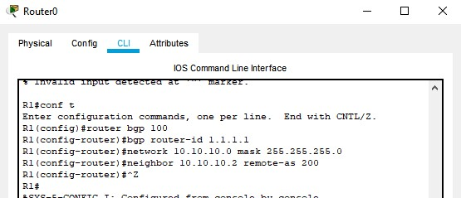

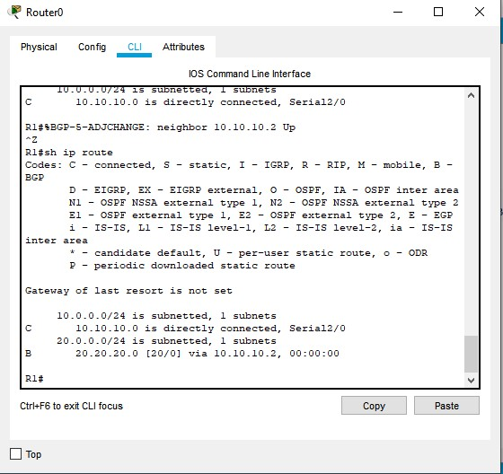

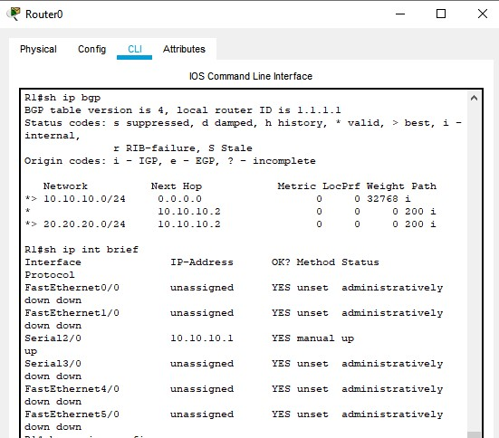

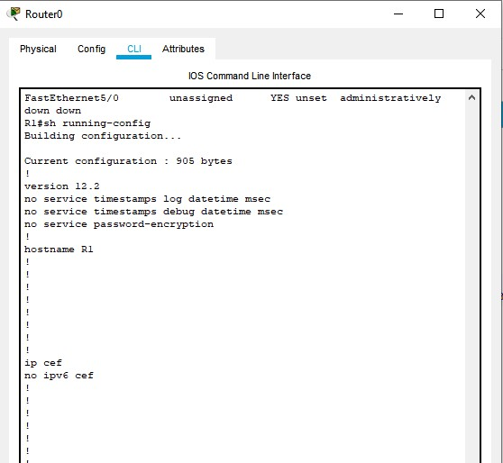

**Router1**

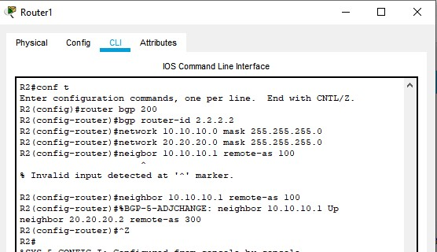

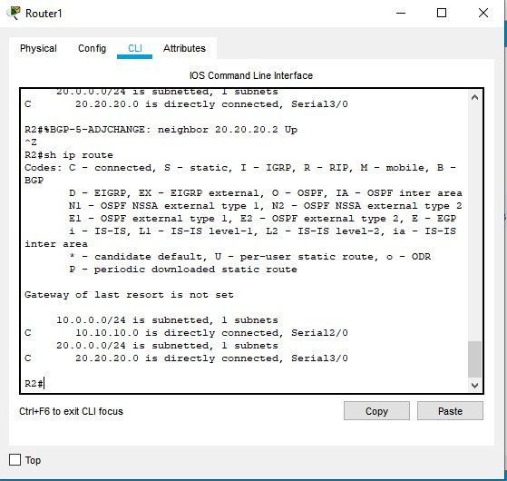

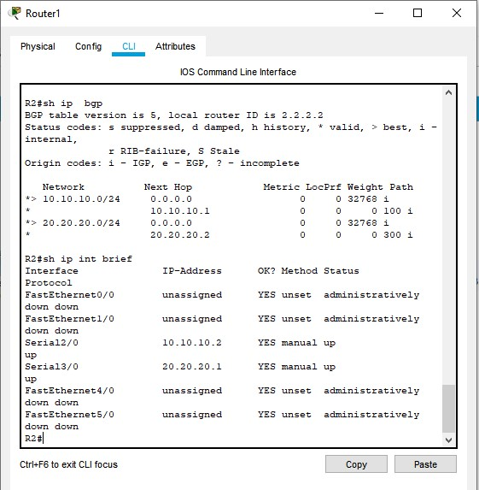

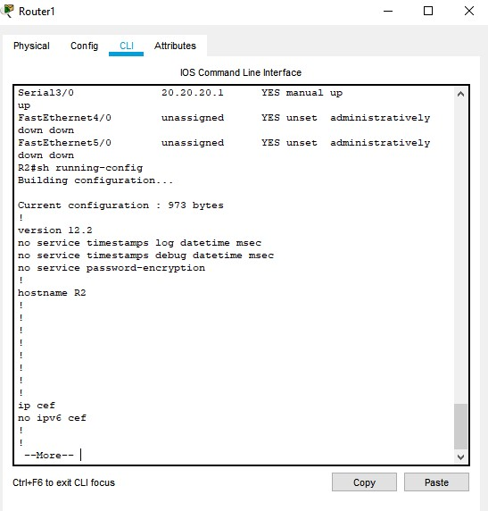

**Router2:**

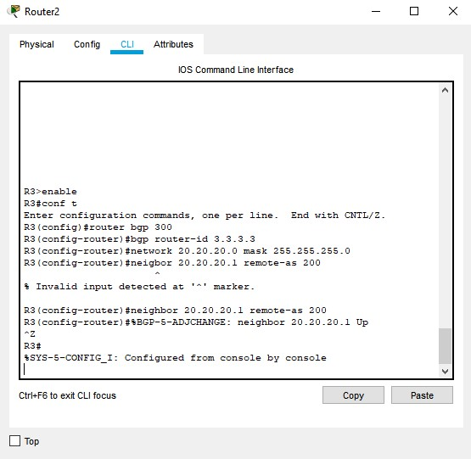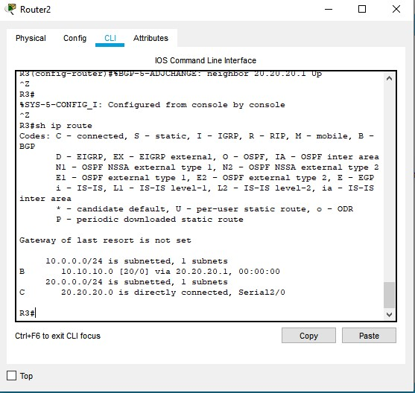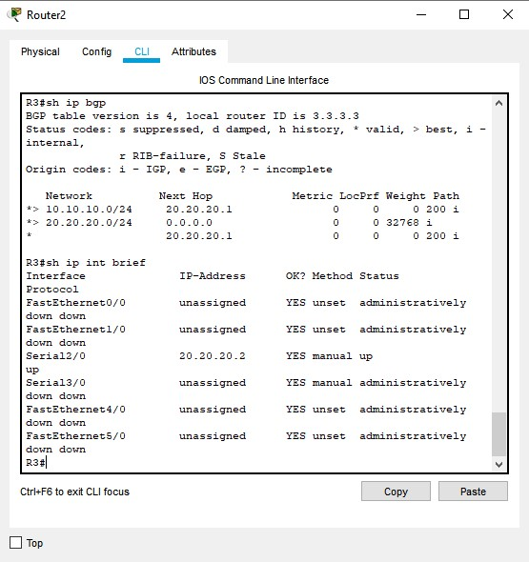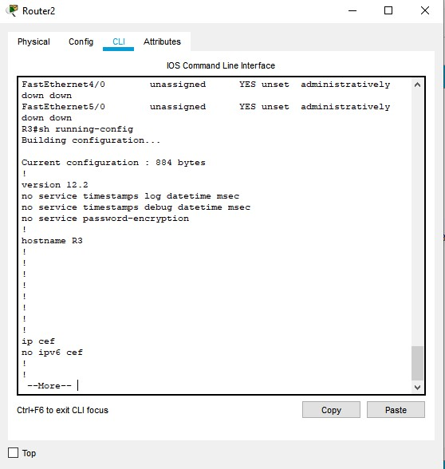

**Ping respone:**

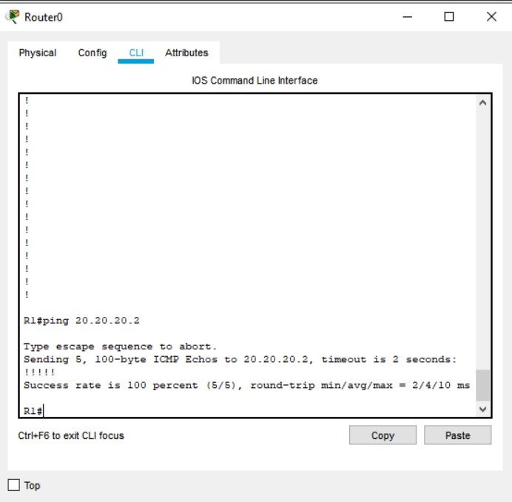

**CONCLUSION:**

Simulation of dynamic routing protocols (bgp) using cisco packet tracer was performed Successfully.